PS629E
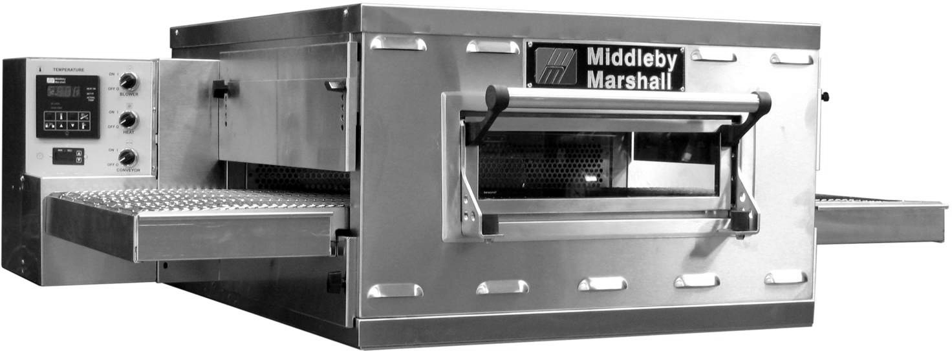
Space Saver WOW! Fast Bake Conveyor Oven

Principle

The Middleby Marshall WOW! conveyor series oven utilizes VAF technology that allows the user full control of the air flow in the baking chamber, resulting in optimal results in cooking product. Air flow is modified through the main control, allowing instant results and full control of air movement, time, and temperature settings. The exterior of the oven is cool to the touch, safely giving users cooler working conditions in the immediate area. The WOW! oven is designed to cook an endless amount of food products including pizza, chicken, seafood, sandwiches and more.

General Information
The PS629 conveyor oven is ideally suited for Kiosk and express-style locations where smaller ovens are required. Stackable to four high.

Standard Features
- Patented EMS Energy Management System* reduces
energy consumption and increases cooking efficiency
- 28” (711mm) long cooking chamber with 18”(457.2mm) belt
- 50”(1270mm) long, 40-3/4”(1035mm) deep, and
21-3/4”(552.4mm) high overall dimensions
- Furnished with 4”(101.6mm) legs
- Digital controls
- Stainless steel front, sides, top and interior
- Reversible conveyor direction
- 12”(304.8mm) Extension Tray
- 15”(381mm) wide front window

Optional Features
- Large legs with casters
- Extended warranty available
- 6”(152.4mm) Extension Tray

Rev 1 (3/18)

Conserves Energy
Unit incorporates a patented Energy Management System - EMS. Middleby ovens provide very efficient heat transfer to product. Energy is conserved as air is recycled from heater to product, with minimum loss. Oven is cool to the touch.

Cleanability
PS629 Ovens are designed for easy cleaning. Removable parts include: crumb pans, end panels, air fingers, exit tray, and a removable conveyor belt assembly.

Easily Services
Control compartment is designed for quick and easy access.

Warranty
All PS629 models have a one year parts and labor warranty.

Ventilation
Use of a ventilation hood is strongly recommended.

1400 Toastmaster Drive Elgin, IL 60120 USA
(847) 741-3300 Fax: (847) 741-0015
www.middleby-marshall.com

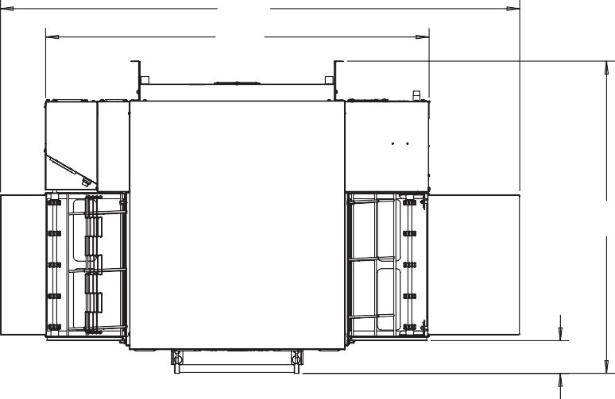
68
1727mm
49.94
1285mm

40.74
1035mm

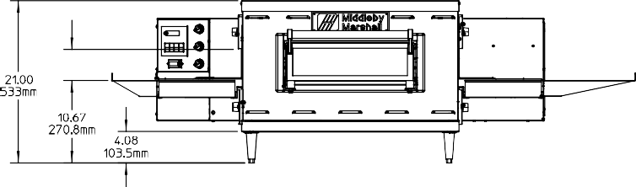
PS629-1

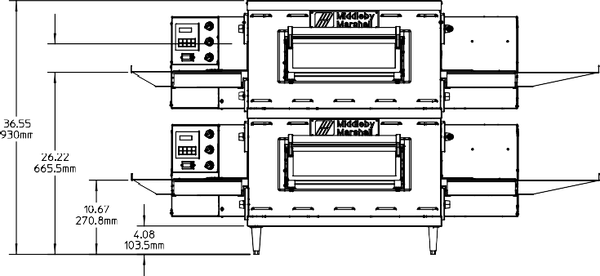
PS629-2

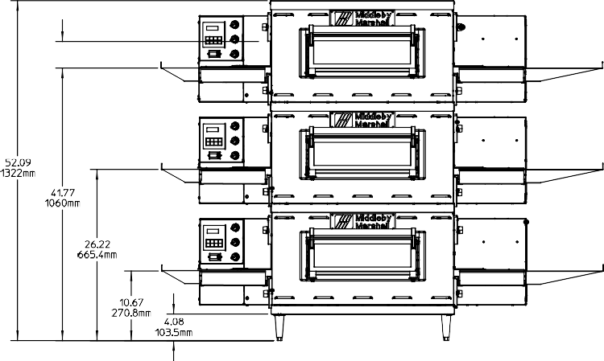
PS629-3

29.75
756mm

14.20
361mm
4.28
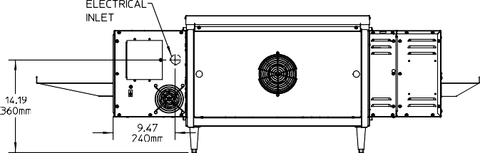
109mm

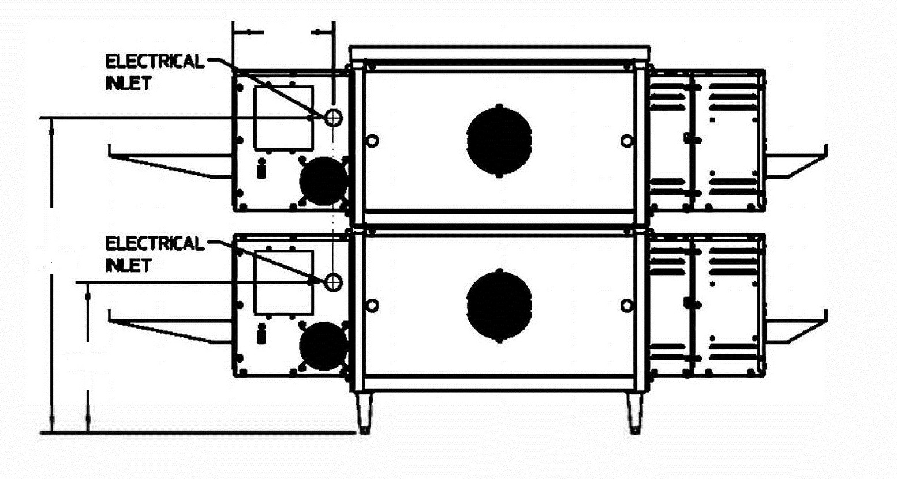
9.47
241mm

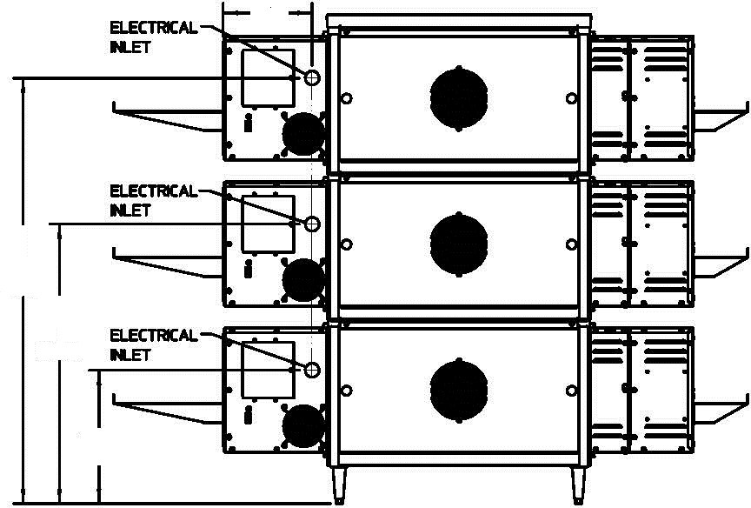
9.47
241mm

45.30
1151mm

29.75
756mm

14.20
361mm

Rev 1 (3/18)

PS629-1 with Optional Legs

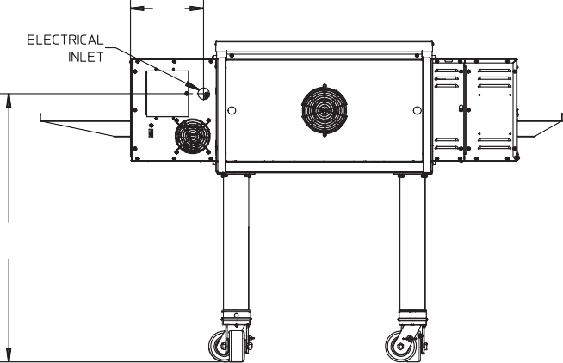
9.47
241mm

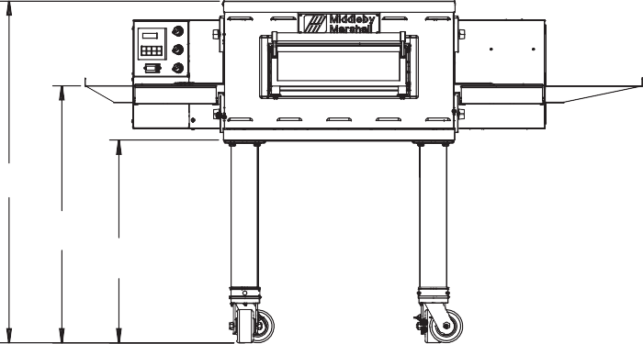
41.59
1056mm

31.27
794mm

24.67
627mm

34.78
83mm

PS629-2 with Optional Legs

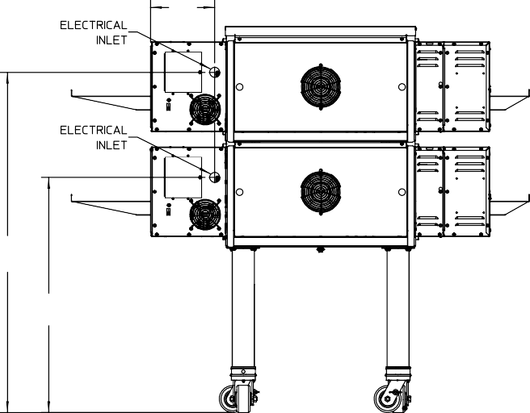
9.47

241mm

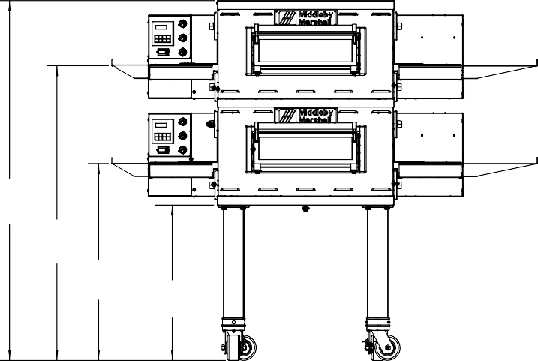
57.94
1472mm

46.81
189mm

31.27
794mm 24.67
627mm
50.33
1278mm
34.78
883mm

Rev 4 (10/15)

PS629E Series Electric Counter Top Conveyor Oven

PS629-3 with Optional Legs

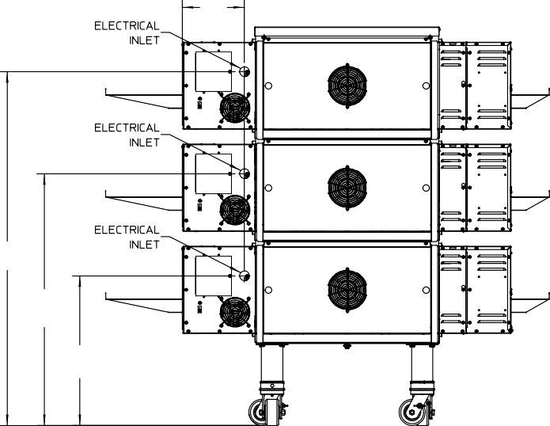
9.47
241mm

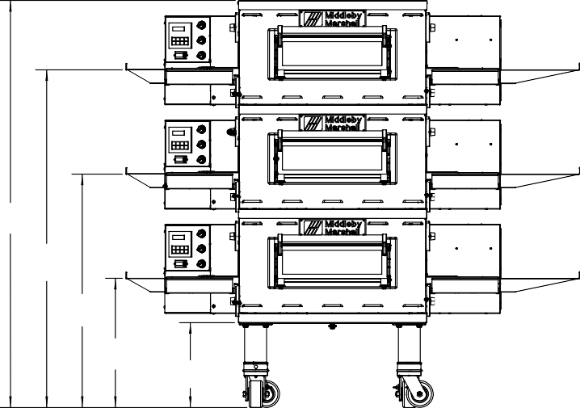
60.69
1542mm

50.36

53.88
1369mm

1279mm

34.81

38.33
974mm

884mm

19.27
489mm

12.67
322mm

22.78
579mm

PS629-4 with Optional Legs

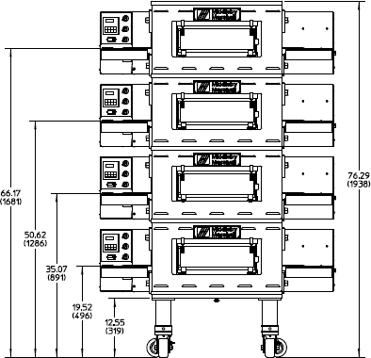
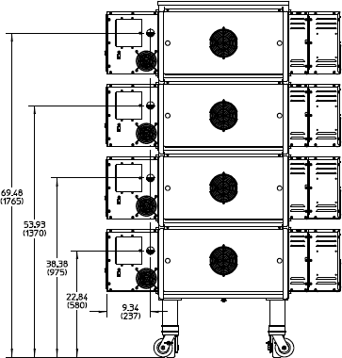

Rev 1 (3/18)

PS629E Series Electric Counter Top Conveyor Oven

RECOMMENDED MINIMUM CLEARANCES

Rear of Oven to Wall | Control end of conveyor to wall | Non-control end of conveyor to wall
0” | 0” | 0”

GENERAL SPECIFICATIONS
 | Heating Zone | Baking Area | Belt Length | Belt Width | Overall Length exit trays installed | Height 4" legs installed | Depth | Maximum Operating Temp | Bake Time Range | Ship Wt | Ship Cube
PS629-1 | 29” | 3.5 sq ft | 50” | 18” | 68” | 21.00” | 40.74” | 6000F | 1-30 min | 325 lbs | 22.1 ft3
 | 737mm | 0.33 sq m | 1270 mm | 457mm | 1727mm | 533mm | 1035mm | 3160C |  | 147.42kg | 0.62m3
PS629-2 | 58” | 7.0 sq ft | 50” | 18” | 68” | 36.55” | 40.74” | 6000F | 1-30 min | 650 lbs | 44.2 ft3
 | 1473mm | 0.66 sq m | 1270 mm | 457mm | 1727mm | 930mm | 1035mm | 3160C |  | 294.48 kg | 1.24m3
PS629-3 | 87” | 11.5 sq ft | 50” | 18” | 68” | 52.09” | 40.74” | 6000F | 1-30 min | 975 lbs | 66.3 ft3
 | 2210mm | 0.99 sq m | 1270 mm | 457mm | 1727mm | 1322mm | 1035mm | 3160C |  | 442.25 kg | 1.86m3
PS629-4 | 116” | 15.0 sq ft | 50” | 18” | 68” | 76.29" | 40.74” | 6000F | 1-30 min | 1,300 lbs | 88.4 ft3
 | 2946mm | 1.32 sq m | 1270 mm | 457mm | 1727mm | 1938mm | 1035mm | 3160C |  | 589.67 kg | 2.48m3

ELECTRICAL SPECIFICATIONS
Main Blower & Control Circuit Phase Frequency kW Amperage Supply Breakers
Elements Voltage | Voltage |  |  |  |  | L1 | L2 | L3 | N
208-240V | 208-240 | 3 Ph | 50/60 Hz | 208 | 12 | 35.3 | 35.3 | 33.3 | - 3 pole 4 wire as per local
 |  |  |  |  |  |  |  |  | (3 hot, 1 grd) codes
 |  | 3 Ph | 50/60 Hz | 240 | 12 | 30.8 | 30.8 | 28.8 | - 3 pole 4 wire as per local
 |  |  |  |  |  |  |  |  |  | (3 hot, 1 grd) | codes
380V Export | 208-240V | 3 Ph | 50/60 Hz | 380 | 12 | 20.2 | 18.2 | 18.2 | 2.0 | 4 pole 5 wire | as per local
(3 hot, 1neu, 1 grd) codes
208-240V | 208-240 | 1 Ph | 50/60 Hz | 208 | 10 | 48.1 | 48.1 2 pole 3 wire as per local  (2 hot, 1 grd) codes
 | EXPORT CE | 1 Ph | 50/60 Hz | 230 | 9.2 | 40.0 | 40.0 2 pole 3 wire as per local
 |  |  |  |  |  |  | (2 hot, 1 grd) codes
 |  | 1 Ph | 50/60 Hz | 240 | 10 | 41.7 | 41.7 2 pole 3 Wire as per local
 |  |  |  |  |  |  |  |  |  | (2 hot, 1 grd) | codes

* The current draw rating shown above are maximum values for normal operation, amperage draw will be less than the listed value.

Optional 6 ft cord with NEMA# 15-50P plug for 208-240V 3ph ovens. Customer to provide NEMA# 15-50R receptacle.

ALL SPECIFICATIONS SUBJECT TO CHANGE WITHOUT NOTICE.
© 2018 Middleby Marshall, Inc.
Middleby Marshall, in accord with its policy to continually improve its products, reserves the right to change materials or specifications without notice. Such revisions do not entitle the buyer to correspond- ing changes, improvements, additions, or replacements for previously purchased equipment.
1400 Toastmaster Drive, Elgin, IL 60120-9272, USA • (847) 741-3300
Fax: (847) 741-0015 Rev 1 (3/18) www.middleby-marshall.com.com

